Material Science Research

In order to decide what materials should be used for my products, a number of properties of the material must be investigated, in order to perform a decision made with the requisite research. Though in essence the product was not too endure huge forces or stresses, it was still important to complete research to ensure that the product would not break under these forces. Additionally, by maximising the efficiency of use of material, finding the exact material to meet my specifications means that I would be able to produce the best product possible.

The definition of material strength is the point at which the material no longer shows a relationship in a Stress-Strain diagram, and thus no longer obeys Hooke’s Law. This means that upon releasing the load from the material it will no longer return to the point that it was before the application of the strain, instead there will be a deformation. Another possible definition, though less used, of the material strength is a function which defines the point at which the object will ultimately fracture, thus no longer satisfying the purpose at all. In addition to the specific moduli of reponses to stresses, one must consider whether the material is isotropic. Especially since my product will likely have a relatively constant stress as there would be no specific external stresses applied other than the normal usage stresses, which though may be concentrated upon specific regions, will not have extremely high pressures, isotropic materials would seem to be a perfect fit. However, depending on the geometry of the exact design, orthotropic materials (where the properties are different at right angles) would also be symmetrical

**Stress:** When a load is placed upon a bar, as in Figure 2a, this induces a number of internal stresses, which are known as the Tension forces. When a plane (mn) is introduced, in Figure 2b, the internal forces (σ) arises from the intermolecular forces that counter the external forces that attempt to distort the body, and return the body to its normal shape. At this point: Σσ = 2F, as the object is in equilibrium, with no result deformation, presuming it is below the elastic limit of the object. In the same way as this works for tensions in Figure 2a and B, the same logic works for compressions, in Figure 3a and 3b.

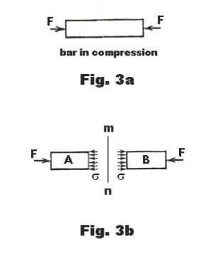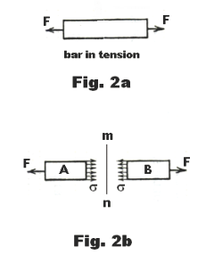

In addition to the Tensile and Compressive stress, there is also shear stress, where equal and opposite forces act on an object from opposite ends. The shear stresses are the forces that resist the tendency for one part of a body to slide over another. Thus, one can generate the following equations:

$$Tension: Stress =E (Young^{'}s Modulus) ϵ$$

$$Compression:Stress=K \left(Bulk Modulus\right) ϵ$$

$$Shear:Shear Stress \left(τ\right)=G \left(Shear Modulus\right) γ$$

Much of the consideration of which of the following is the most important very much results from the chosen geometry of the piece. For example, an ergonomic design, designed to be held in both hands, in a tight position will likely result in increases in Tension strains, thus, meaning that the Young’s Modulus and Bulk Modulus of the material. On the other hand, if the geometry promotes the user using both hands to grasp the device from top and bottom, the shear rate would be more likely to become important, thus requiring us to look at the Shear Modulus of the product.

On the other hand, though relatively easy to evaluate, it is obvious that the Poisson’s Ratio and ductility of the material should not have an impact on the mechanics of the product, as we continue to assume that the scale of the forces would not be large enough to have such an impact upon the product. In fact, based upon some preliminary research, based upon the idea of the size of the product not being disimlar to that of a Mobile Phone, and in fact the impact being very similar, with both having similar usages, the forces are very low. For example, if a touchscreen were to be used, the average force applied by a finger on the screen would be 1.04 – 3.64N. Though the grasp of the hands could contribute to a higher total compression stress, statistics are not easily available, thus experimentation should be carried out to evaluate this. This could be relativally easily completed, using a couple of force-meters and an object, with a size similar to the product being produced.

Once the information has been found, the requirements can be combined with the desired specifications for the product, such as a light weight design, and relatively low costs. Ashby plots are being used to attempt to evaluate a number of materials. Figure 2x and 3x allow us to find materials which are boath relatively cheap while meating the nead of Young’s Modulus, which can be derived using the above equation. From both pieces of information, it is clear that an ideal material would likely be derived the polymers section since they seem to combine a high enough Young’s Modulus, thereby resistance to tension, and with low enough densities, thus allowing the product to be light and portable. In addition, to be considered is the manufacturing properties of various materials, especially the various pros and cons of specific polymers, given that the material of choice is likely to descend from that particular group.

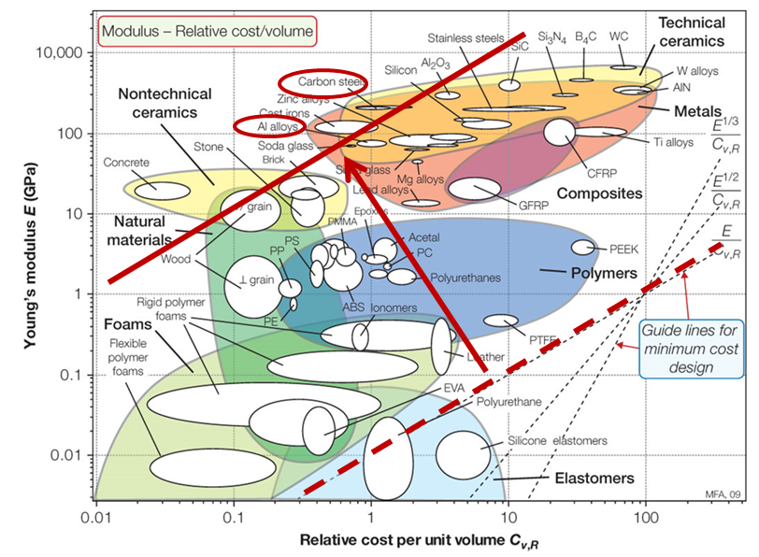

Figure 2x

